A structured GAP analysis showing the most viewed categories and the top 10 articles per category.
- Categories with the Most Views
Across all the files, these categories stand out for very high readership:

Insights
- Governance & Politics is overwhelmingly dominant, largely due to the pages on Idi Amin and Museveni - 9,700,000+ views
- Ugandan People overlap with politics, but it is also a huge driver (over 2.3M).
- Economy, Society, Health, and Environment each sit in the 200k–500k range, showing balanced demand.
- Education and Buildings/Infrastructure are smaller but strategically important for community impact.
- History is modest but still relevant for the depth of context.

Here is a bar chart, visualizing the total views per category from the GAP analysis by views.
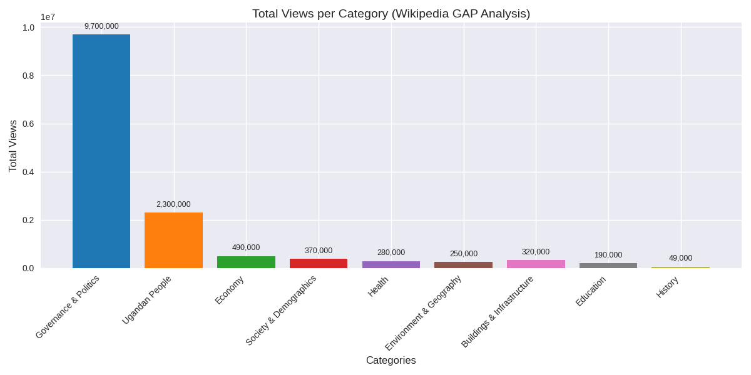

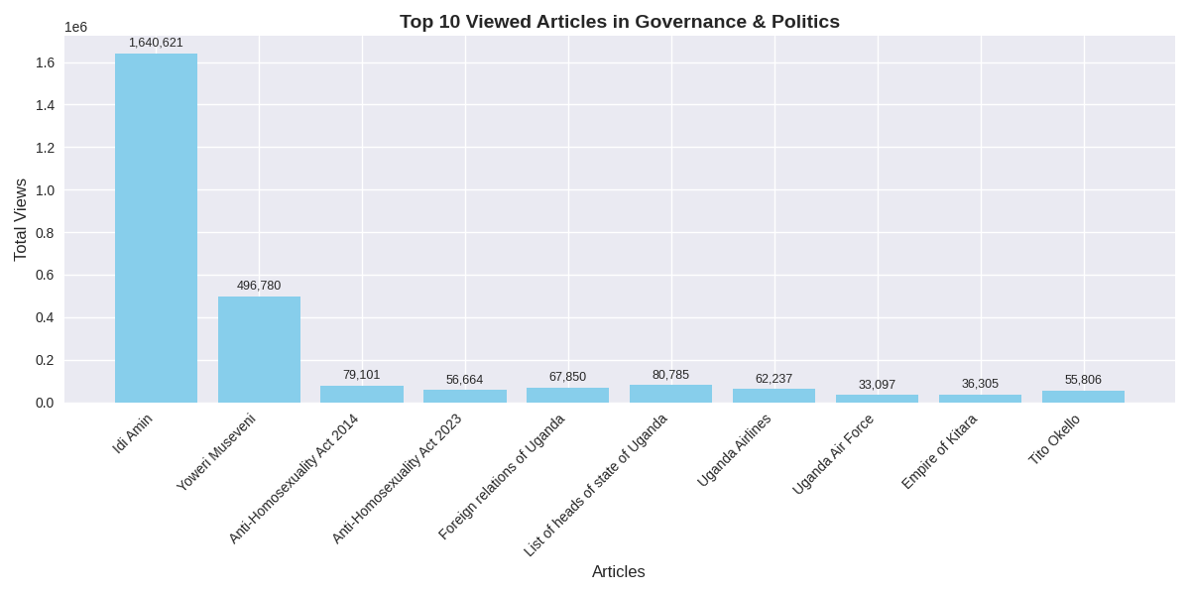
- Top 10 Articles by View

i) Governance & Politics
1. Idi Amin – 1,640,621
2. Yoweri Museveni – 496,780
3. Anti-Homosexuality Act, 2014 – 79,101
4. Anti-Homosexuality Act, 2023 – 56,664
5. Foreign relations of Uganda – 67,850
6. List of heads of state of Uganda – 80,785
7. Uganda Airlines – 62,237
8. Uganda Air Force – 33,097
9. Empire of Kitara – 36,305
10. Tito Okello – 55,806

ii) Economy
1. List of Ugandans by net worth – 107,060
2. East African shilling – 26,871
3. Ugandan shilling – 46,476
4. Umeme – 46,501
5. Uganda Railway – 44,143
6. Economy of Uganda – 35,153
7. Uganda Revenue Authority – 12,954
8. Uganda Bureau of Statistics – 18,924
9. Uganda National Oil Company – 26,743
10. Mining industry of Uganda – 5,346
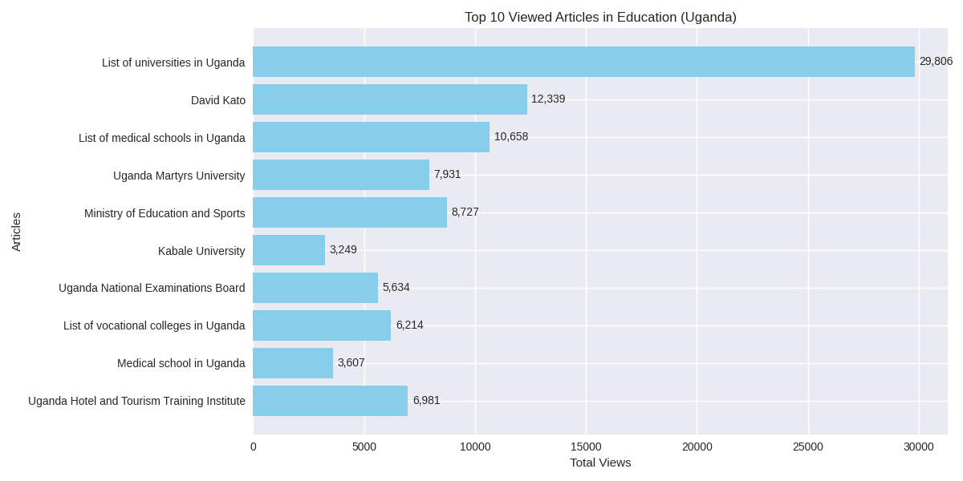
iii) Education
1. List of universities in Uganda – 29,806
2. David Kato – 12,339
3. List of medical schools in Uganda – 10,658
4. Uganda Martyrs University – 7,931
5. Ministry of Education and Sports – 8,727
6. Kabale University – 3,249
7. Uganda National Examinations Board – 5,634
8. List of vocational colleges in Uganda – 6,214
9. Medical school in Uganda – 3,607
10. Uganda Hotel and Tourism Training Institute – 6,981
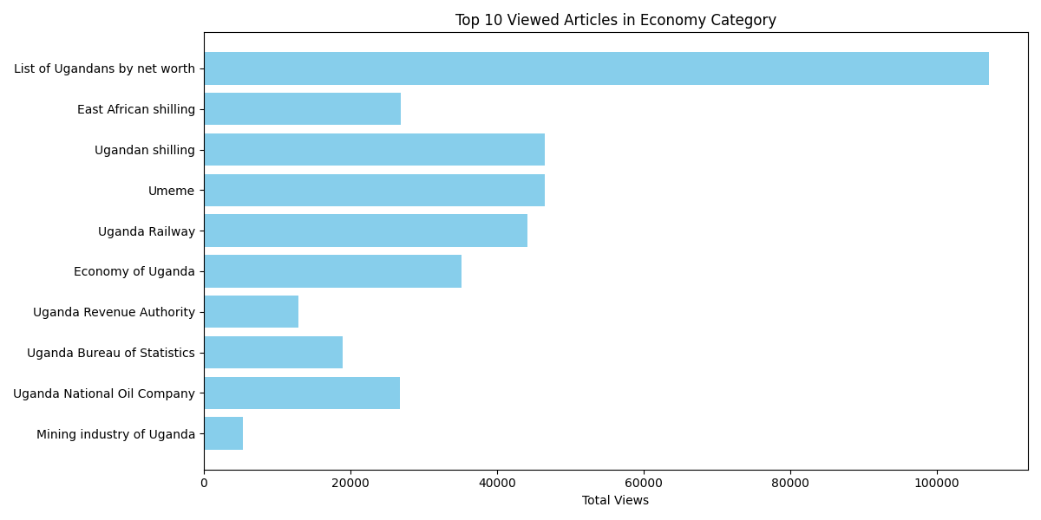

iv) Health
1. President’s Emergency Plan for AIDS Relief – 50,080
2. Healthcare in Uganda – 25,338
3. HIV/AIDS in Uganda – 23,777
4. Uganda AIDS Commission – 26,602
5. Lucille Teasdale-Corti – 26,298
6. Child health in Uganda – 29,933
7. Child sacrifice in Uganda – 22,228
8. Serving His Children – 14,895
9. Roy Mugerwa – 17,213
10. The AIDS Support Organization – 11,171

v) Environment & Geography
- Water supply & sanitation (79,809)
- Floating island (75,073)
- Albertine Rift (19,457)
- Bwindi Impenetrable Forest (17,936)
- Water politics in Nile Basin (10,607)
- East Sudanian savanna (8,836)
- Wildlife of Uganda (7,169)
- East African montane forests (5,599)
- Fishing industry (3,040)
- Zika Forest (2,798)

vi) Buildings & Infrastructure
- Entebbe International Airport (111,612)
- List of tallest buildings in Kampala (23,053)
- Uganda Advanced Certificate of Education (8,720)
- Karuma Hydroelectric Power Station (7,576)
- Kabalega International Airport (6,832)
- Battle of Entebbe (6,466)
- List of power stations (6,101)
- Miracle Centre Cathedral (5,716)
- Uganda Certificate of Education (5,322)
- University of East Africa (3,524)

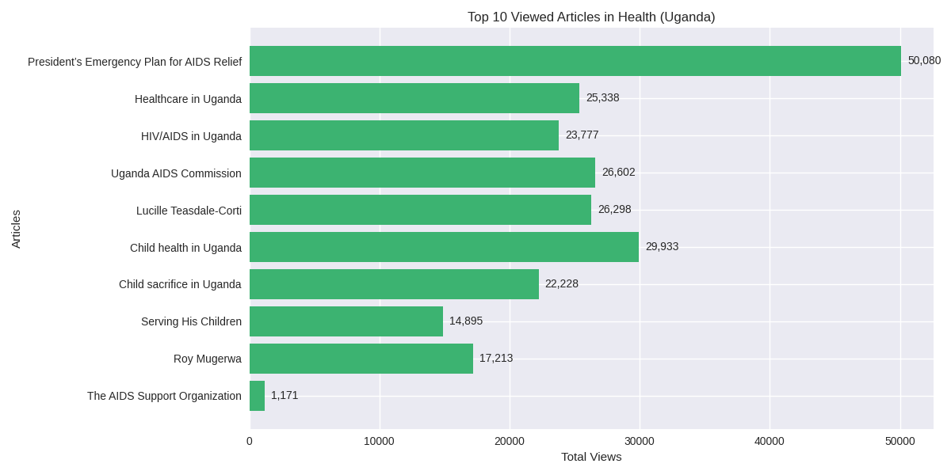

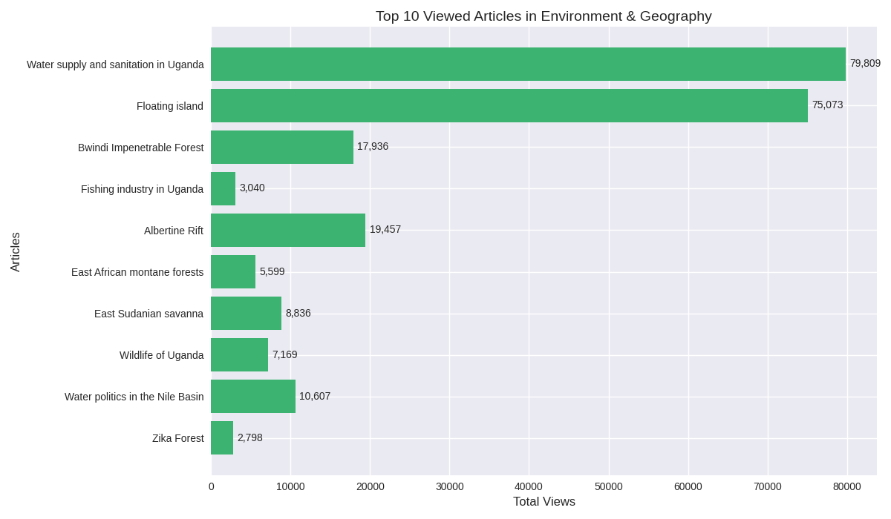

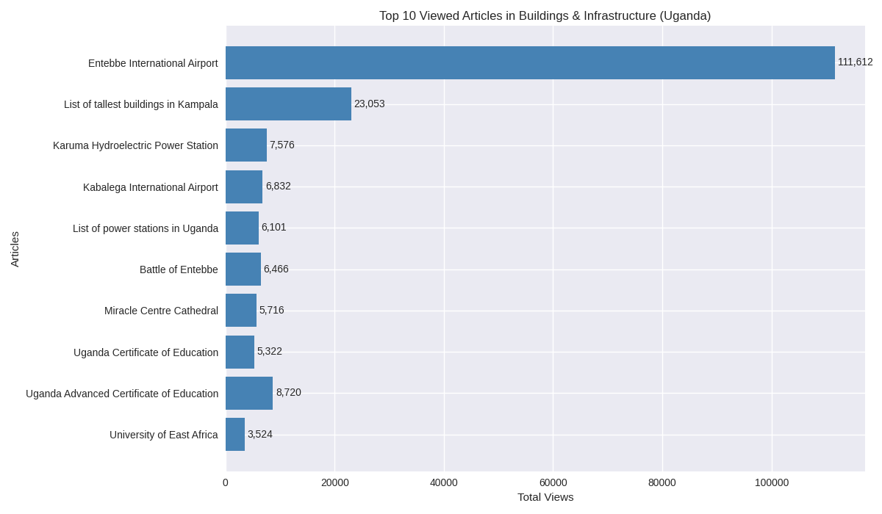

vii) Society & Demographics
- Save the Children (150,456)
- Acholi people (61,641)
- Bunyoro (39,817)
- Demographics of Uganda (45,742)
- Empire of Kitara (36,305)
- Busoga (34,470)
- GiveDirectly (24,183)
- Prostitution in Uganda (9,080)
- Women in Uganda (8,370)
- Masaba people (5,489)

VIII) Ugandan People
- Idi Amin (1,640,621)
- Yoweri Museveni (496,780)
- Milton Obote (206,124)
- Yusuf Lule (46,405)
- Tito Okello (55,806)
- Ntare IV of Nkore (1,128)
- Paul Ngologoza (1,107)
- Kyebambe IV of Bunyoro (807)
- Ruhinda of Ankole (878)
- Kezia of Buganda (792)

IX) History
- Uganda Protectorate (27,973)
- Lado Enclave (23,386)
- Presidential Commission (22,601)
- Kingdom of Rwenzururu (2,597)
- Uganda Cowries (1,611)
- Bukono kingdom (236)
- Bukooli Chiefdom (175)
- Ugandan monarchies (N/A)

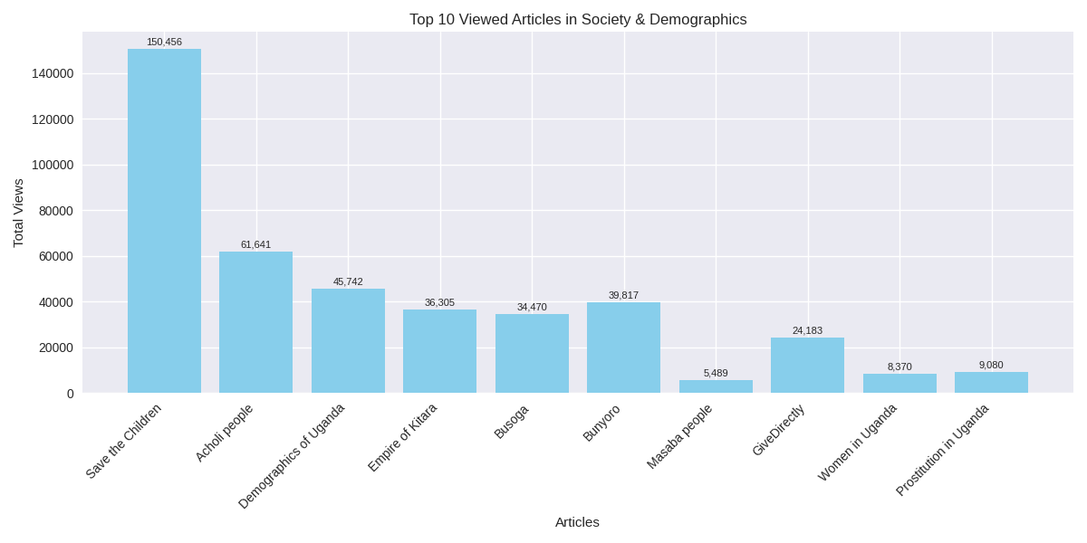

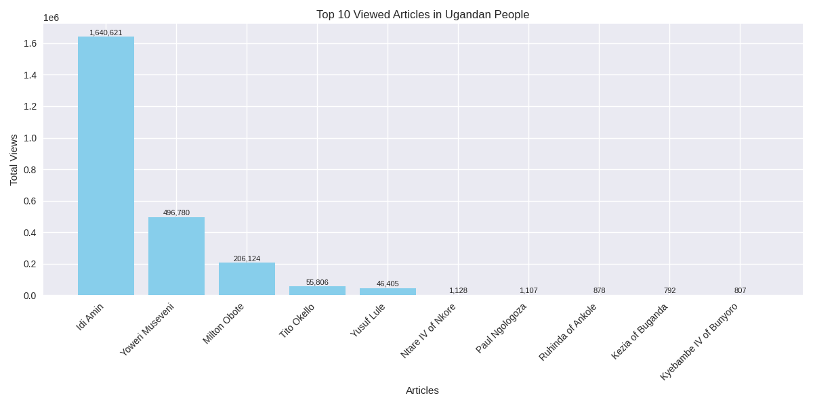

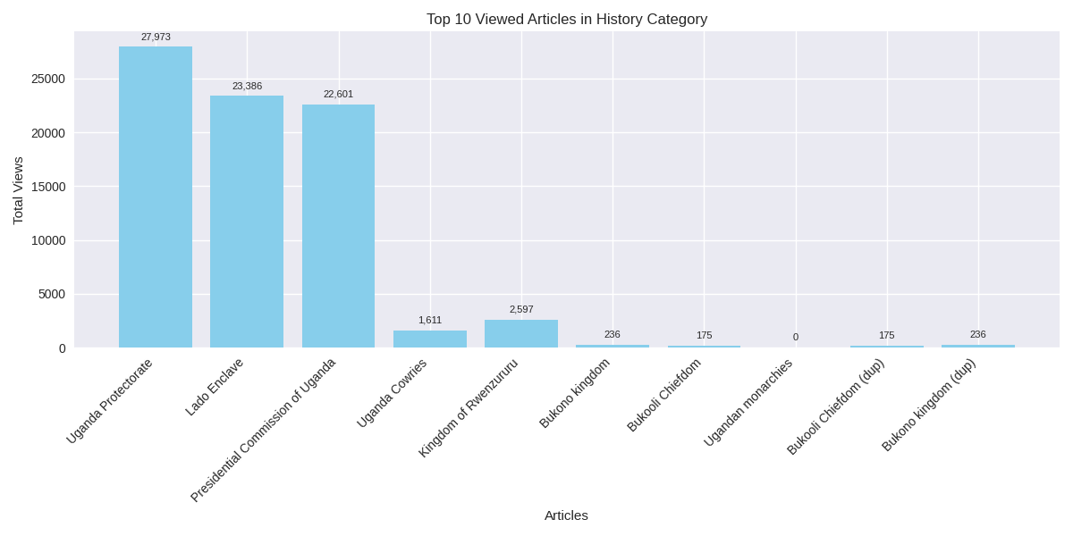

What the View Analysis Tells Us

- Public Interest Priorities: Biographies of leaders dominate the top searches on Ugandan knowledge i.e., Idi Amin, Museveni, Obote… This means that readers are most curious about Uganda’s political figures and historical leadership.
- Institutions and infrastructure matter: Airports, universities, NGOs, and health programs attract high traffic. This means that people seek practical knowledge about systems that shape everyday life.
- Cross‑Category Themes: Politics and governance overlap with society: Laws like the Anti‑Homosexuality Acts and NGOs like Save the Children show how governance directly connects to social issues.
- Knowledge Gaps & Opportunities: Some categories (like History) have relatively low views compared to Politics or People, suggesting less public engagement with heritage topics, but this presents an opportunity to raise awareness and improve content.
- Niche articles (like chiefdoms or ecosystems) have a small but steady readership.
- High‑impact articles (leaders, laws, airports, universities, NGOs) should be prioritized for sourcing and improvement.
- Under‑read but culturally vital articles (chiefdoms, monarchies, biodiversity) should be enriched to ensure representation.

